**KONERU LAKSHMAIAH EDUCATIONAL FOUNDATION**

**(DEEMED TO BE UNIVERSITY)**



**Department of Computer Science Engineering**

Course code -15CS2007

**Database Systems**

II B. Tech – 2nd Semester

Academic Year 2017-2018

Project Based Lab

ON

**GLOBAL HOSPITALS**

Submitted by

Section – 8

Batch No: 4

**Student Name**

CH.VIJAYA LAKSHMI (160030231)

CH. MAHITHA (160030235)

CH. POOJA (160030267)

**KONERU LAKSHMAIAH EDUCATIONAL FOUNDATION**

**(DEEMED TO BE UNIVERSITY)**

**DEPARTMENT OF COMPUTER SCIENCE ENGINEERING**

**(DST-FIST Sponsored Department)**



**CERTIFICATE**

This is to certify that the course based project entitled **GLOBAL HOSPITALS** is a bonafide work done by **CH.Niharika (160030200)** in partial fulfilment of the requirement for the award of degree in **BACHELOR OF TECHNOLOGY** in **Computer Science Engineering** during the academic year **2017-2018.**

**Faculty In Charge Head of the Department**

**G.V.S. Narayana Dr.E.Suresh Babu**

**DEPARTMENT OF COMPUTER SCIENCE ENGINEERING**

**(DST-FIST Sponsored Department)**



**DECLARATION**

We hereby declare that this project based lab report entitled **GLOBAL HOSPITALS** has been prepared by us in partial fulfilment of the requirement for the award of degree “**BACHELOR OF TECHNOLOGY in COMPUTER SCIENCE ENGINEERING**” during the academic year 2017-2018.

We also declare that this project based lab report is of our own effort and it has not been submitted to any other university for the award of any degree.

**Date: 21-03-2018**

**Place: Vaddeswaram**

**ACKNOWLEDGMENT**

My sincere thanks Mr.G.V.S. Narayana in the Lab for their outstanding support throughout

the project for the successful completion of the work

We express our gratitude to Dr. E. Suresh Babu, Head of the Department for Computer

Science and Engineering for providing us with adequate facilities, ways and means by which

we are able to complete this term paper work.

We would like to place on record the deep sense of gratitude to the honourable Vice

Chancellor, K L University for providing the necessary facilities to carry the concluded term

paper work.

Last but not the least, we thank all Teaching and Non-Teaching Staff of our department and

especially my classmates and my friends for their support in the completion of our term paper

work.

**Table of Contents**

|  |  |
| --- | --- |
| **CONTENTS** | **PAGE NO** |
| Abstract | 6 |
| Introduction | 7 |
| ER-Diagram | 8 |
| Schema Diagram | 9 |
| Creation and Insertion of SQL Queries | 10-11 |
| SQL Queries related to Report Generation | 12-14 |

**ABSTRACT**

In this project, we have to design and develop a database for the hospital to maintain the records of various departments, rooms, and doctors in the hospital. This database includes the details of nurses, compounders, and other staff working in the hospital It also maintains records of the regular patients, patients admitted in the hospital, the check-up of patients done by the doctors, the patients that have been operated, and patients discharged from the hospital. The hospital consists of different types of rooms, departments and OPD. This hospital maintains an insurance division and it maintains a blood bank also.

From the description of hospital management we have to identify major data requirements, entities, attributes and relationship between those entities. We also have to develop ER models as part of conceptual design and realize the ER models into schemas as part of logical design and apply normalization techniques .We have to create tables with constraints to the identified schemas as part of logical design and have to write SQL queries for this description.

The relationships are:

* There is 1 : N relation between doctor and patient
* There is 1 : N relation between blood bank and patient.
* There is N : 1 relation between bill and patient
* There is 1 : 1 relation between room and patient
* There is N:1 relation between doctor and department
* There is 1:N relation between department and doctor

**INTRODUCTION**

Database is an organized collection of data. The data is typically organized to model aspects of reality in a way that supports processes requiring information. A DBMS makes it possible for end users to create, read, update and delete data in a database. The DBMS essentially serves as an interface between the database and end users or application programs, ensuring that data is consistently organized and remains easily accessible. The DBMS manages three important things: the data, the database engine that allows data to be accessed, locked and modified and the database schema, which defines the database’s logical structure. These three foundational elements help provide concurrency, security, data integrity and uniform administration procedures. The DBMS can offer both logical and physical data independence. That means it can protect users and applications from needing to know where data is stored or having to be concerned about changes to the physical structure of data.

**ER-DIAGRAM**

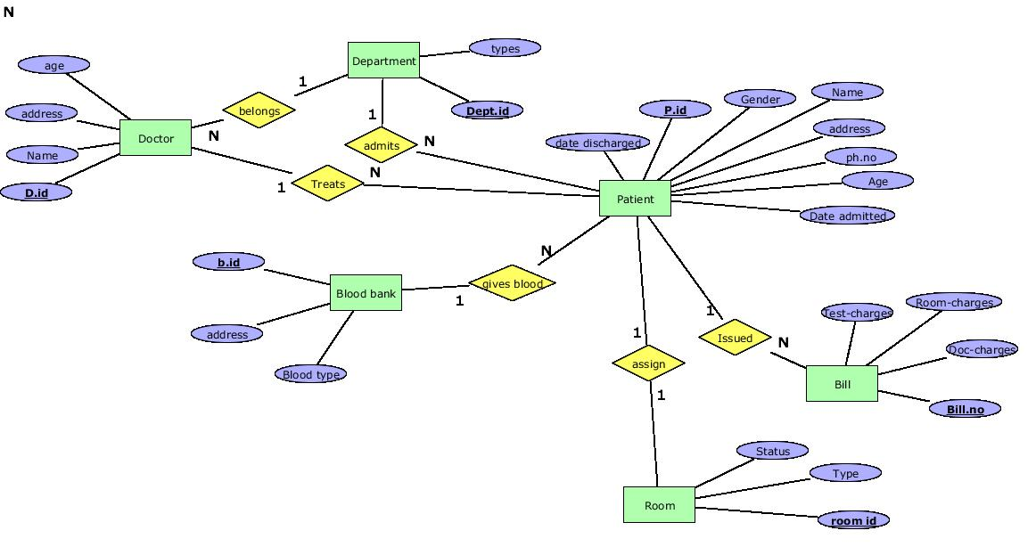

**RELATIONAL SCHEMA**

Doctor

|  |  |  |  |  |  |
| --- | --- | --- | --- | --- | --- |
| **D.id** | **Dept.id** | Name | age | address |  |

Patient

|  |  |  |  |  |  |  |  |  |  |  |
| --- | --- | --- | --- | --- | --- | --- | --- | --- | --- | --- |
| **P.id** | **D.id** | **B.id** | **Dept.id** | Name | age | Ph.no | Gender | Date admitted | Date discharged | address |

Department

|  |  |
| --- | --- |
| **Dept.id** | Types |

Room

|  |  |  |  |
| --- | --- | --- | --- |
| **Room.id** | **P.id** | Type | Status |

Bill

|  |  |  |  |  |
| --- | --- | --- | --- | --- |
| **Bill.no** | **P.id** | Test charges | Doc _charges | Room_ charges |

Blood bank

|  |  |  |
| --- | --- | --- |
| **B.id** | address | Blood type |

**SQL QUERIES**

**Create tables for all the entities**

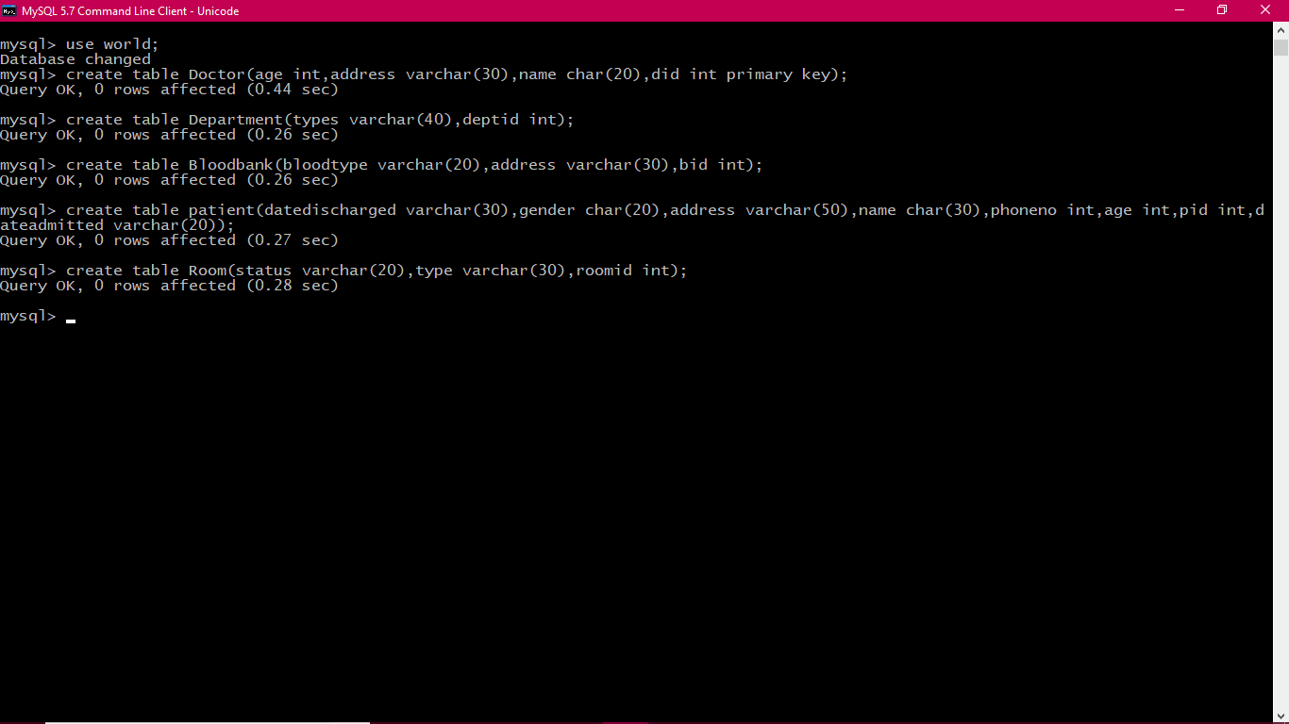

**Insert values into the tables**

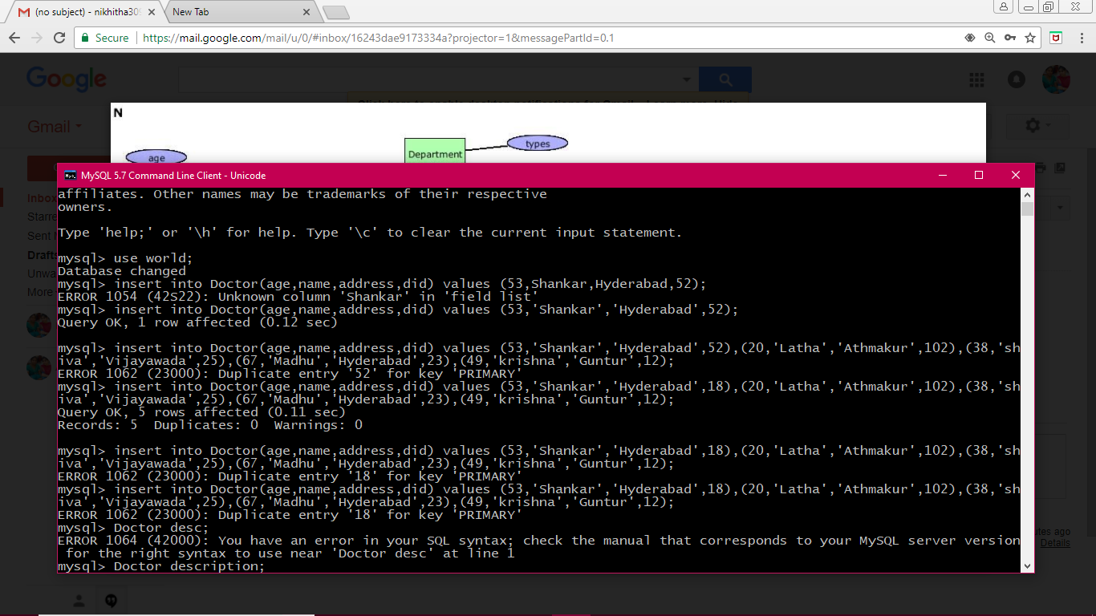

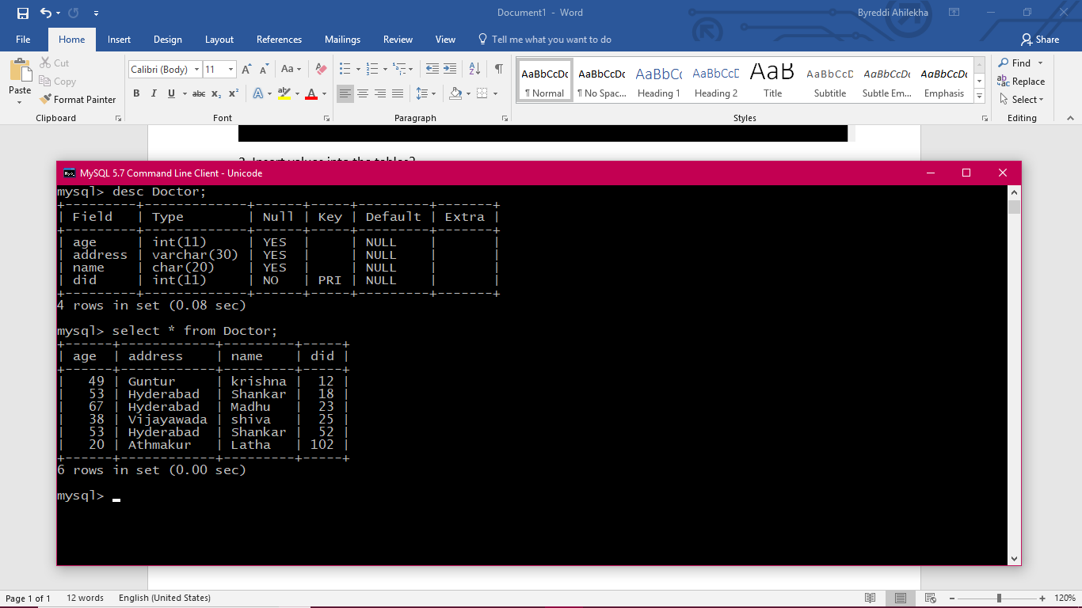

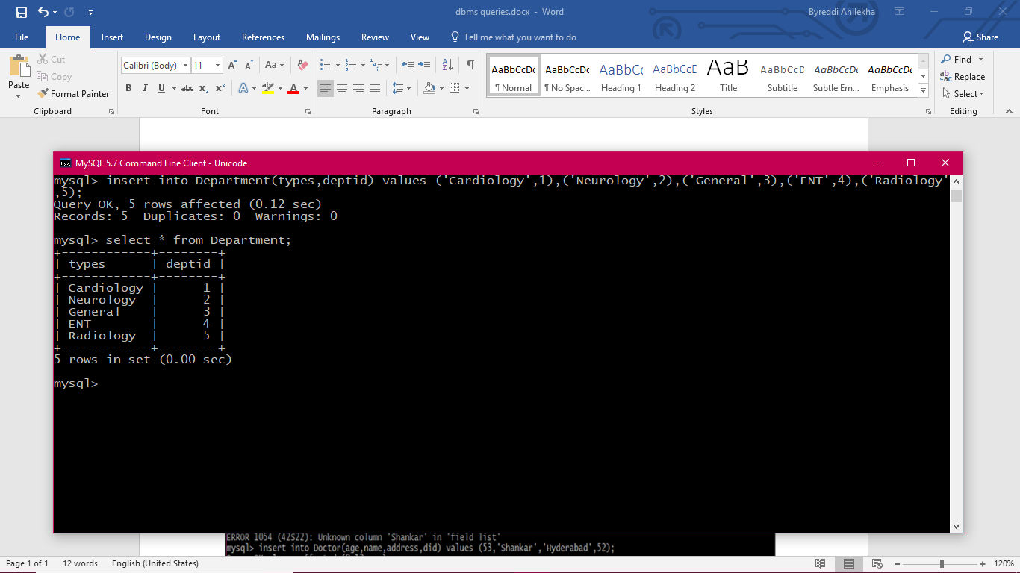

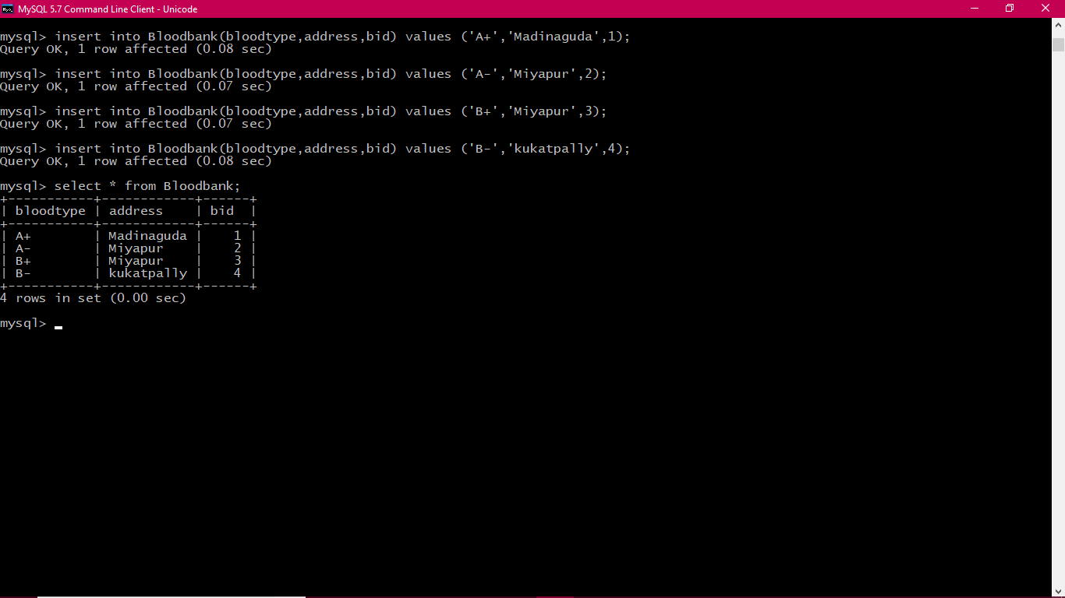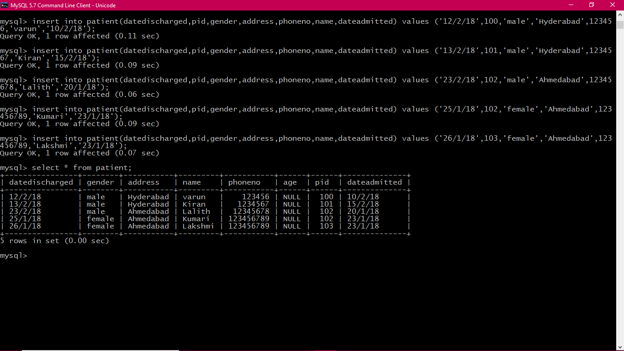

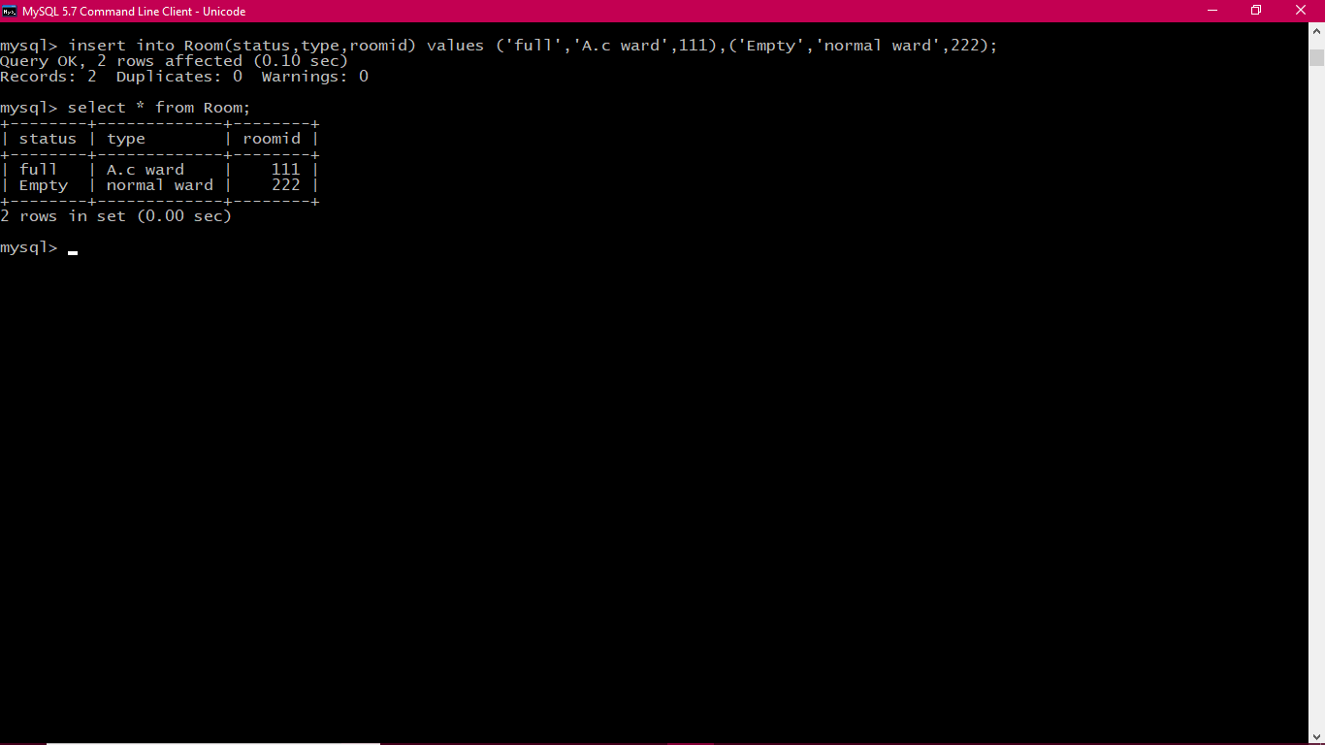

**1. Write a query to select name and phone number of a patient?**

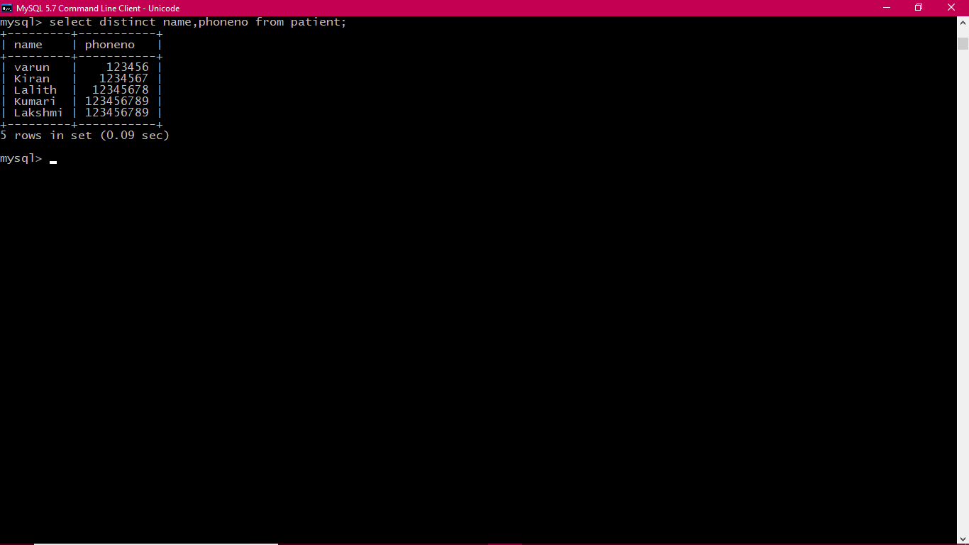

**2. Write a query to change the value of a tuple in the table patient?**

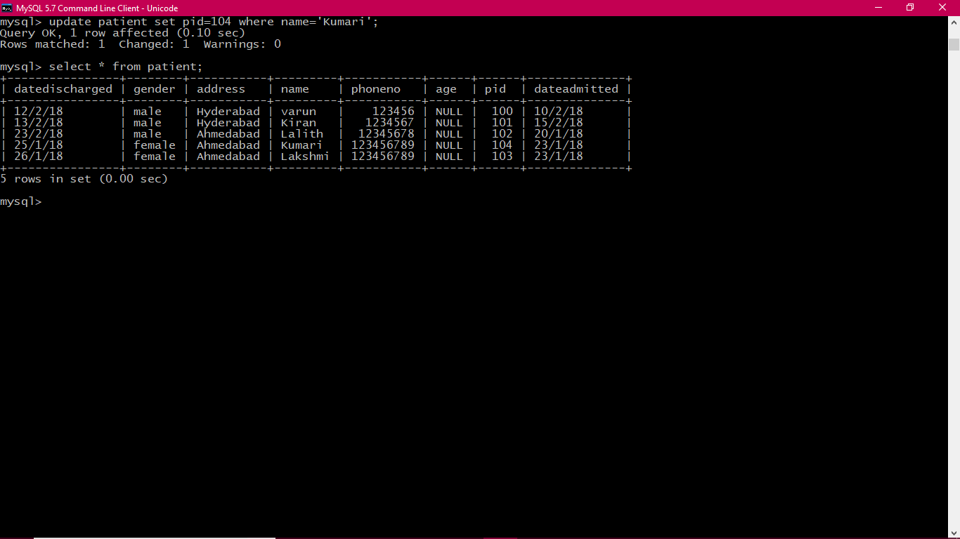

**3. Write a query to know the department types where the department id is greater than 1?**

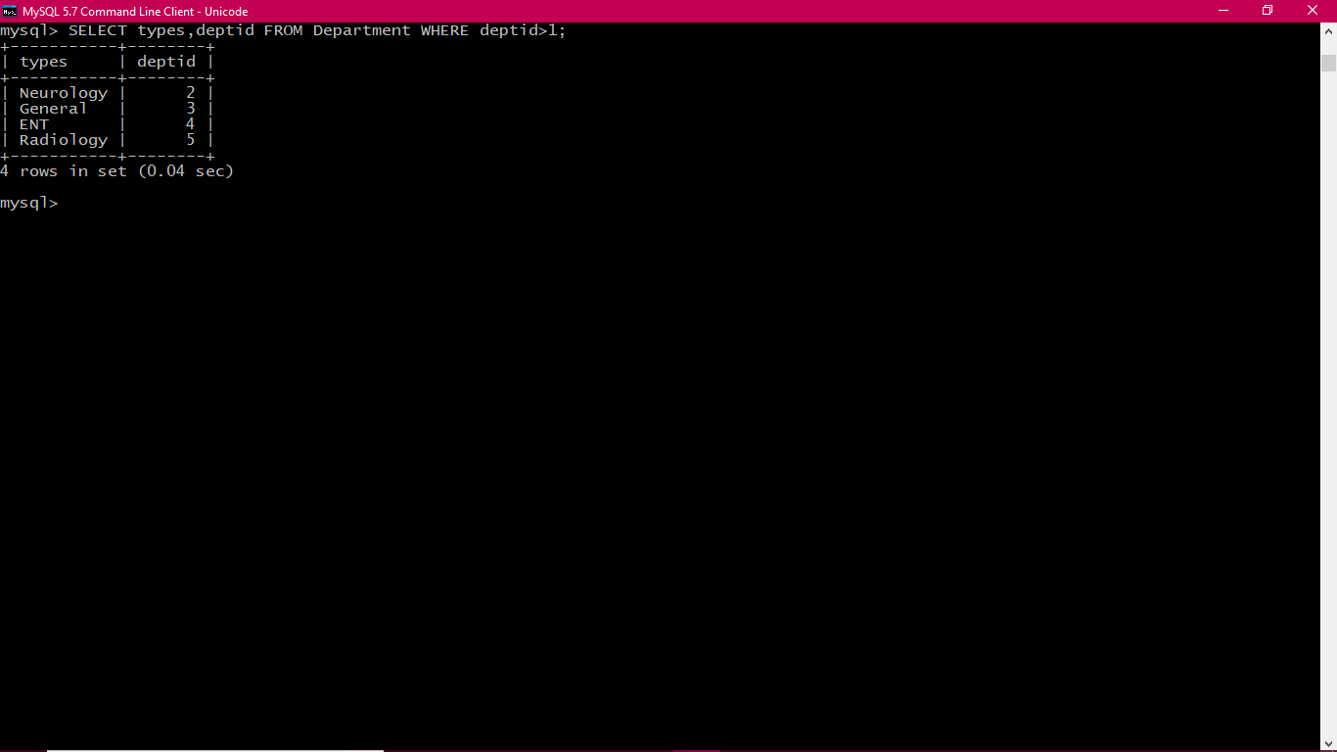

**4. Combine patient id and name and give the alias patient details to the expression.**

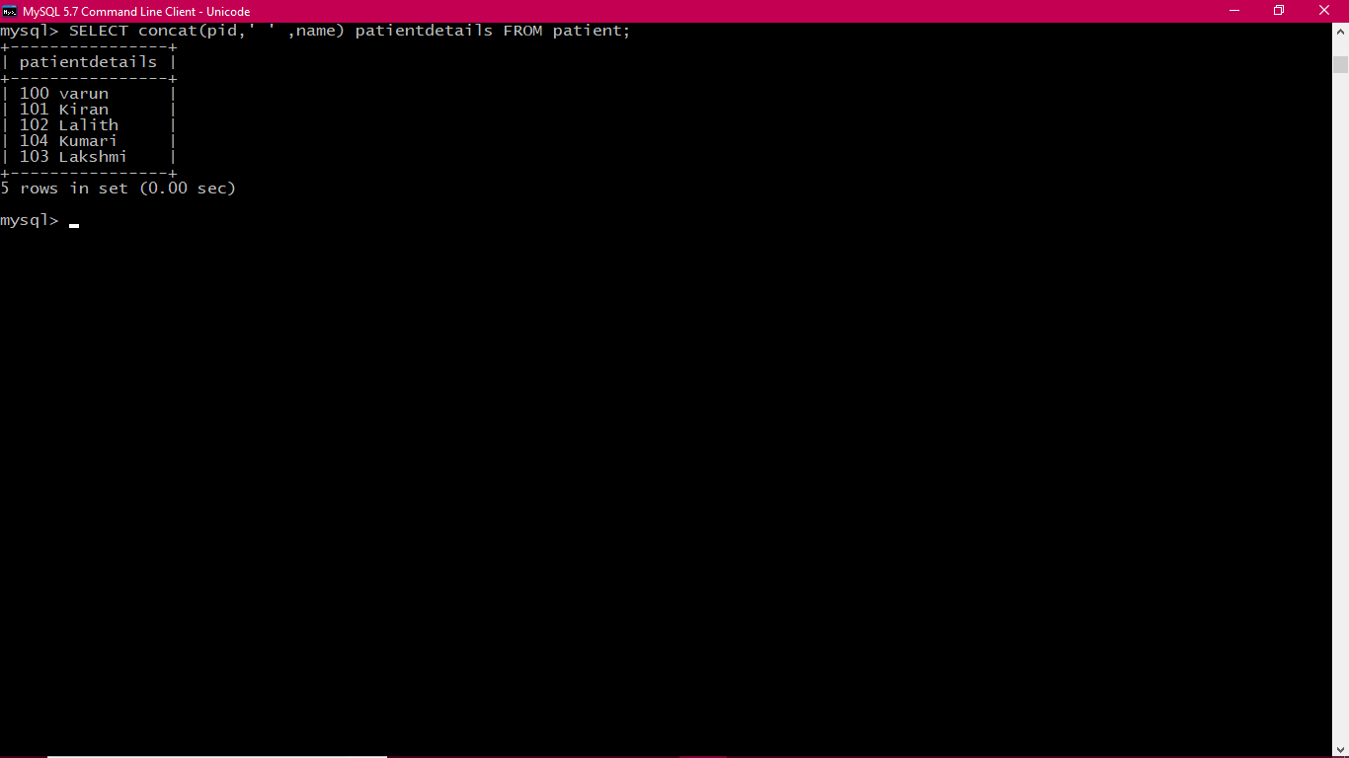

**5.Write a query to display date admitted in descending order?**

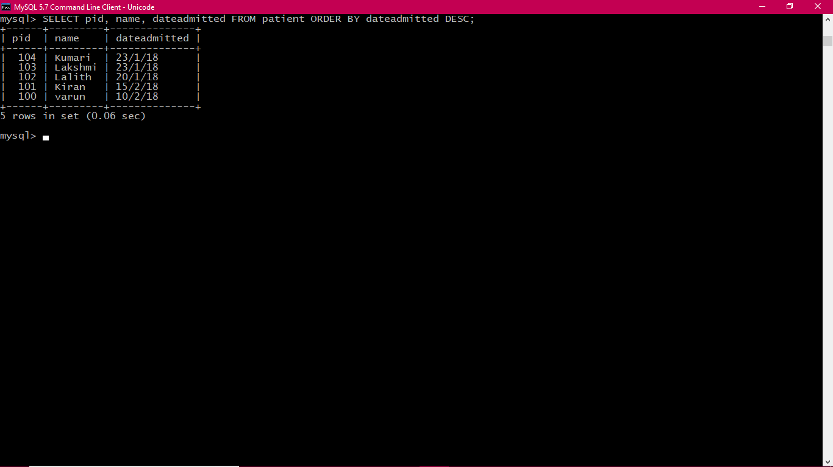

**6 .Display patients name, patient id, address whose pid is between 100 and 103?**

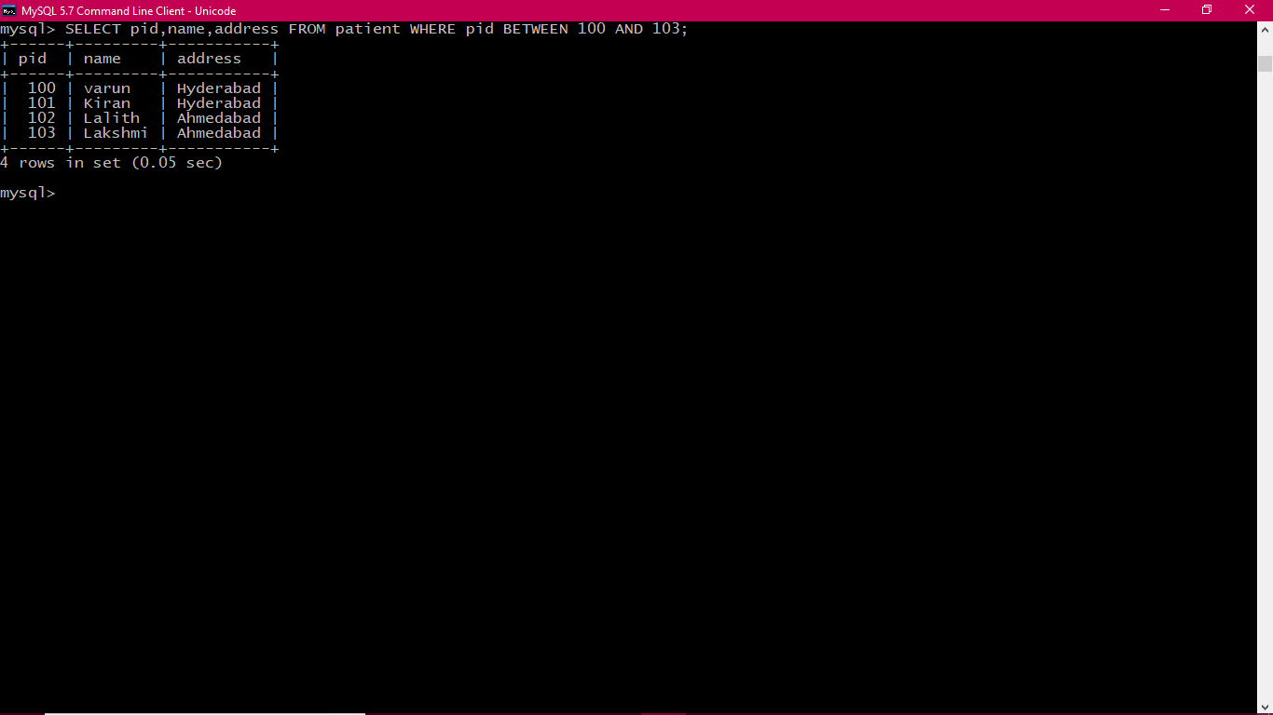

**7. List all the Doctors whose name starts with S.**

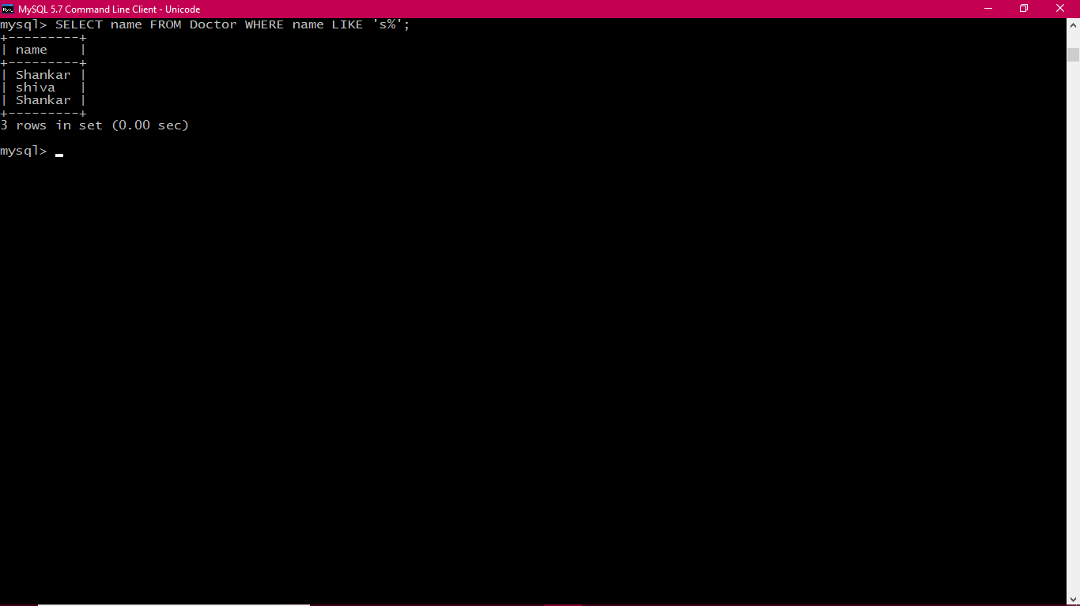

**8. Display patient name and the length of their name?**

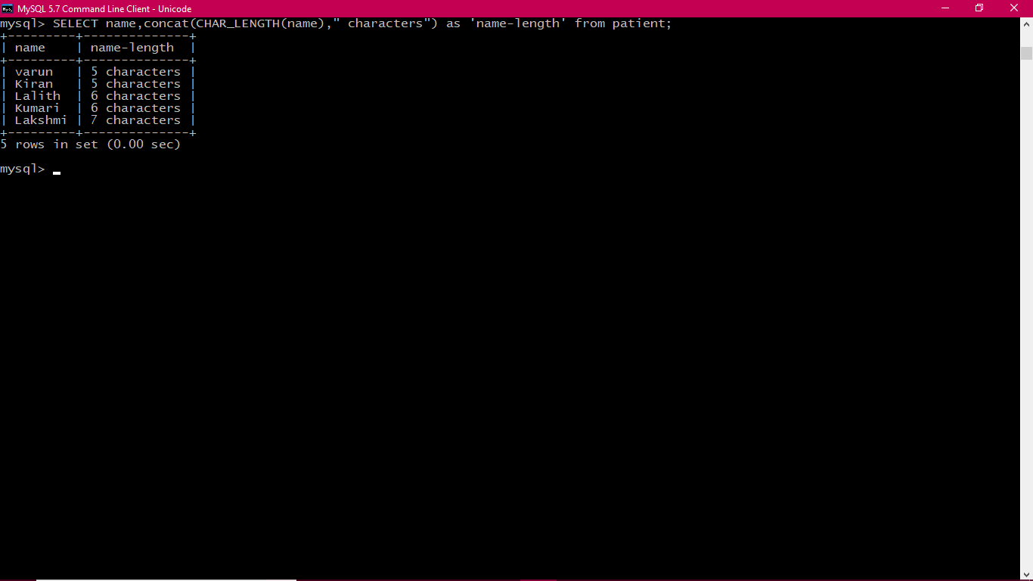

**9. Add column name location to the existing table name patient**

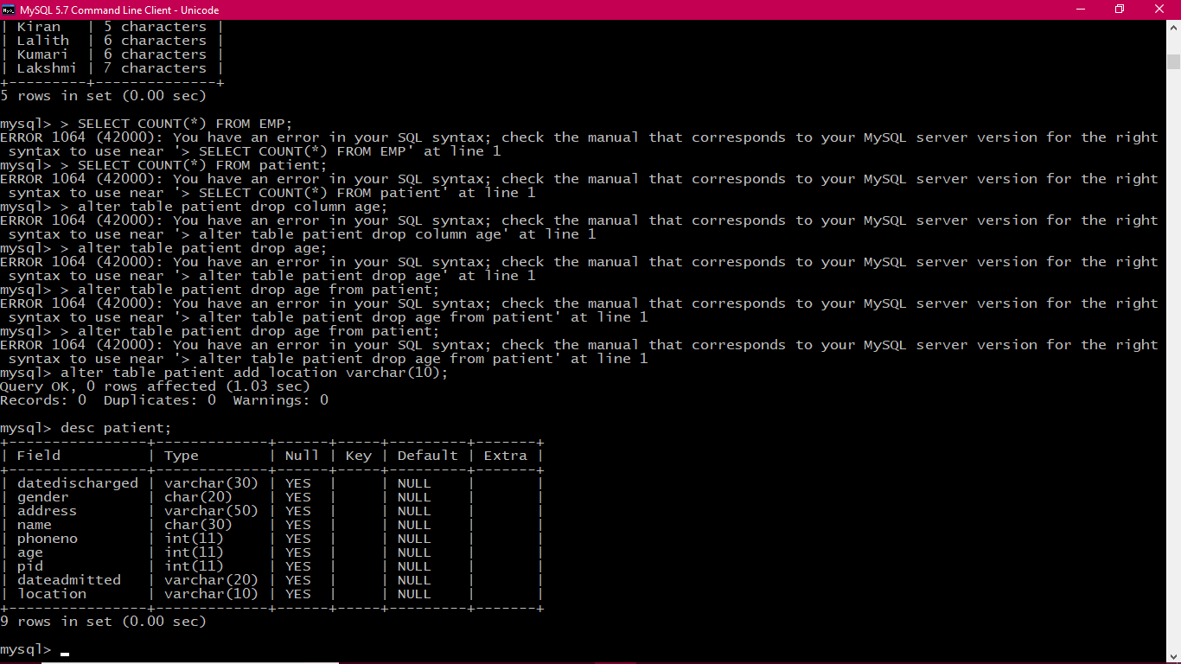

**10.Write a query to force characters in lower case or upper case ?**

